Customer NameDocument Title

INTERNAL
: Resorts World at Sentosa Pte. Ltd.

RWS
TECHNICAL SPECIFICATION – INTERFACE

R2R-AP-I-002b, HR-SF-I-002, HR-SF-I-003, HR-SF-I-004, HR-SF-I-005 – Consolidated TS for S4HANA to NRS and SuccessFactors

Contents
1 Document Organization 5
1.0 Document Log 5
1.1 Integration, Document Reference 5
2 Clean Core Compliance 6
3 Program Attributes 6
3.1 Selection Parameter / Filter 7
3.2 Validation 7
3.2.1 Selection Criteria validations 7
3.2.2 Interface parameter validations 7
3.2.3 Other validations 7
3.3 Authorization Requirements 8
3.4 Definition 8
3.5 Defined Fields 8
3.6 Procedure 8
3.7 Technical Flow Diagram 8
3.8 Processing Logic 8
3.8.1 Validation 8
3.8.2 Mapping 8
3.8.3 Error Handling 8
3.8.4 Custom DDIC Objects 8
3.8.5 Custom CDS View Entity Details 8
3.8.6 BRF+ Design 9
3.9 Reusable Code 9
3.10 File Attributes 9
3.11 Internal Tables 9
3.12 Messages 10
3.13 Selection Text 10
3.14 Text Elements 10
3.15 Subroutines 10
4 Interface List Output 11
4.1 Field Details 11
4.2 Layout 11
4.3 Interface List Header & Footer 11
5 Application logs/Monitoring 11
6 Assumptions in Technical Design 11
7 Open Issues in Technical Design 11
8 Unit Test Results 11
9 Related Documentation 11

Document Organization
This section provides details about this document, previous version(s) of this document and the document(s) referred.

Document Log
Following table mentions the version changes and the processer(s):
Version | Status | Date | Version Created by (Name/E-Mail/Company) | Role | Comments
1.0 | Draft | June 23, 2025 | Ridhima Aggarwal | Author | Initial Draft
 | Choose an item. | Click here to enter a date. |  | Choose an item.

Integration, Document Reference
N/A
S. No. | Referred Document Name | Referred Document Version | Referred Document URL (Optional)

Clean Core Compliance

Final Solution | Category | Comments
 | Choose an item.

Program Attributes
Program title | Vendor address outbound interface
Program Name | ZRFI_VENDOR_ADDRESS_OI
Program Type | Executable
Package | ZFI
Authorization Group
Type of Interface
Mode of Execution | Online/Background

Transaction Code | ZFI_VENDR_ADDR_INT
Include Programs | zrfi_vendor_address_oi_top, zrfi_vendor_address_oi_f01
Function Modules
Message Class

Classes
Generic Classes / Utility Classes
AMDP Classes
Proxy Class
FEH action class
Basic IDoc type
IDoc extension
Custom IDoc segment(s)
AIF Function module
API Name
CDS Name
Behavior Definition
Behavior Implementation Class
Service Definition
Service Binding

Selection Parameter / Filter

Single Valued / Range | Mandatory | Value Help | Default Value | User Text
P_PRC |  |  |  | EAM/EAT/PMM/WMS
P_CMS |  |  |  | eCSS
P_SEND |  |  |  | Send data
P_DEL |  |  |  | Delete logs
S_DATE |  |  |  | Creation/Change On
S_LIFNR |  |  |  | Vendor

Validation

Selection Criteria validations
NA

Interface parameter validations
NA

Other validations
NA

Authorization Requirements
NA

Definition
  - Purpose
The purpose of this interface is to update vendor master data from S/4HANA to various systems (WMS - Warehouse Management System, EAM - Engineering Asset Management(Maximo), PMM – Retail(Eleos), EATEC(RIS) FnB BH Inventory Mgmt(Simphony), Filenet eCSMS)
- This is an outbound interface from SAP S/4HANA.
- Vendor masters are created in SAP S/4HANA.
- The file contains data such as vendor code, name, vendor address, currency etc. Detailed listing of fields required by sub-system and data mapping from SAP vendor master to various system are described in below sections.
- This interface is executed daily, and only vendor masters’ transactions posted after the last/previous successfully executed interface are selected (i.e., delta transactions).
- Only vendor masters’ delta transaction data (i.e., changes / updates to Vendor master data) are interfaced daily; Delta transaction data in the last/previous successfully executed interface need not be sent again.
- The selection of data is controlled by the date of the last successful run of the interface, Vendor creation date or vendor change date. Please refer details given in page 8. Basically, system will select the incremental records created or changed in the table post the last successful interface run and include in the interface.

  - Responsibility
S/4HANA
- Interface data extraction based on existing layout and file format.
- Based on interface configuration table defined in S/4HANA, if the interface requires data transformation from S/4HANA to sub-system values will be determined. Format of the interface configuration table is as follows. Only sample data provided.
Source system number | Source system description | Target system number | Target system description | Interface ID | Data transformation required (Yes / No)
171 | S4H | 24 | WMS | R2R_AP_I_001 | Yes
171 | S4H | 25 | EAM | R2R_AP_I_001 | Yes
171 | S4H | 27 | PMM | R2R_AP_I_001 | Yes
171 | S4H | 28 | EATEC | R2R_AP_I_001 | Yes
171 | S4H |  | eCSMS | R2R_AP_I_001 | Yes
- If the configuration for data transformation is marked as Yes, there will be data transformation tables maintained to map Sub system values to S/4HANA values. Refer section 2.6. If this configuration table does not have entries, it means no data transformation. For example, if the new interfaces are already developed with S/4 values, no need to maintain in this table.
- Configuration table is enhanced to cover all interface aspects including, error notifications (email ids), SFTP adapters. (all information relating to interfaces) such as interface program, iflow program form CPI etc. This is covered as part of a separate interface common design document applicable for all interfaces.
- Based on the mapping tables, AIF will perform the reverse mapping to sub-system fields, if required. For example, S/4 company code to RWS business unit, S/4 Vendor Number to RWS vendor number, etc.
- Data will be generated by S/4 interface program, transformed to Sub-system values based on mapping tables (if required) and immediately connects to CPI to transfer the data using an API / webservices call.
- In case of errors, interface shall be retriggered from S/4 using manual retrigger option.
CPI
- CPI receives the data, converts to csv, encrypts the data and places the encrypted csv file in MFT folder.
Sub-system (SUB-SYSTEM)
- File is moved from MFT folder to NAS and decrypted.
- File is picked up by sub-system from the NAS folder and data is consumed.
- The values received will be in Sub-system Format.
- It is sub-system responsibility to build necessary validations and consume the data.

Procedure
- Run the transaction ZFI_VENDR_ADDR_INT. Below mentioned selection screen will be opened.
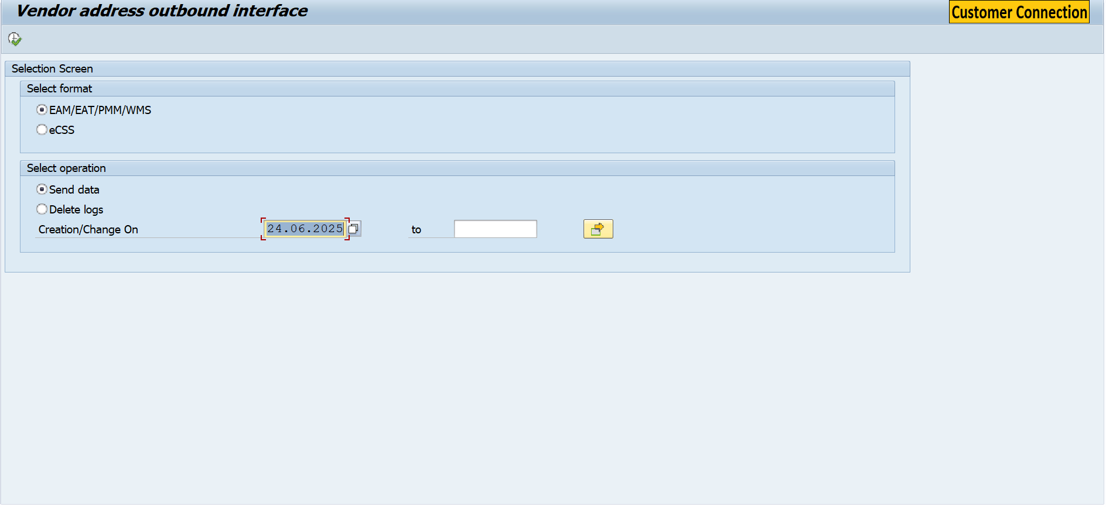
- Depending on the selection the program will send data to CPI or delete logs.
- ALV is displayed.

Technical Flow Diagram
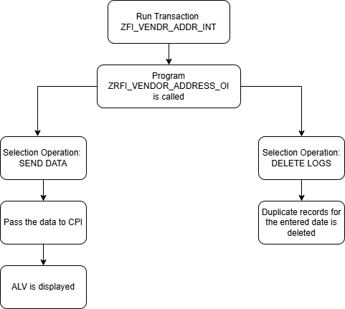

Processing Logic
Run transaction ZFI_VENDR_ADDR_INT. Program ZRFI_VENDOR_ADDRESS_OI will be called as per the radio button selected. Find the below logic in detail as per WRICEF.
- Created Structure ZSFI_CMS_VENDOR_ADDR_OI and ZSFI_PRC_VENDOR_ADDR_OI. 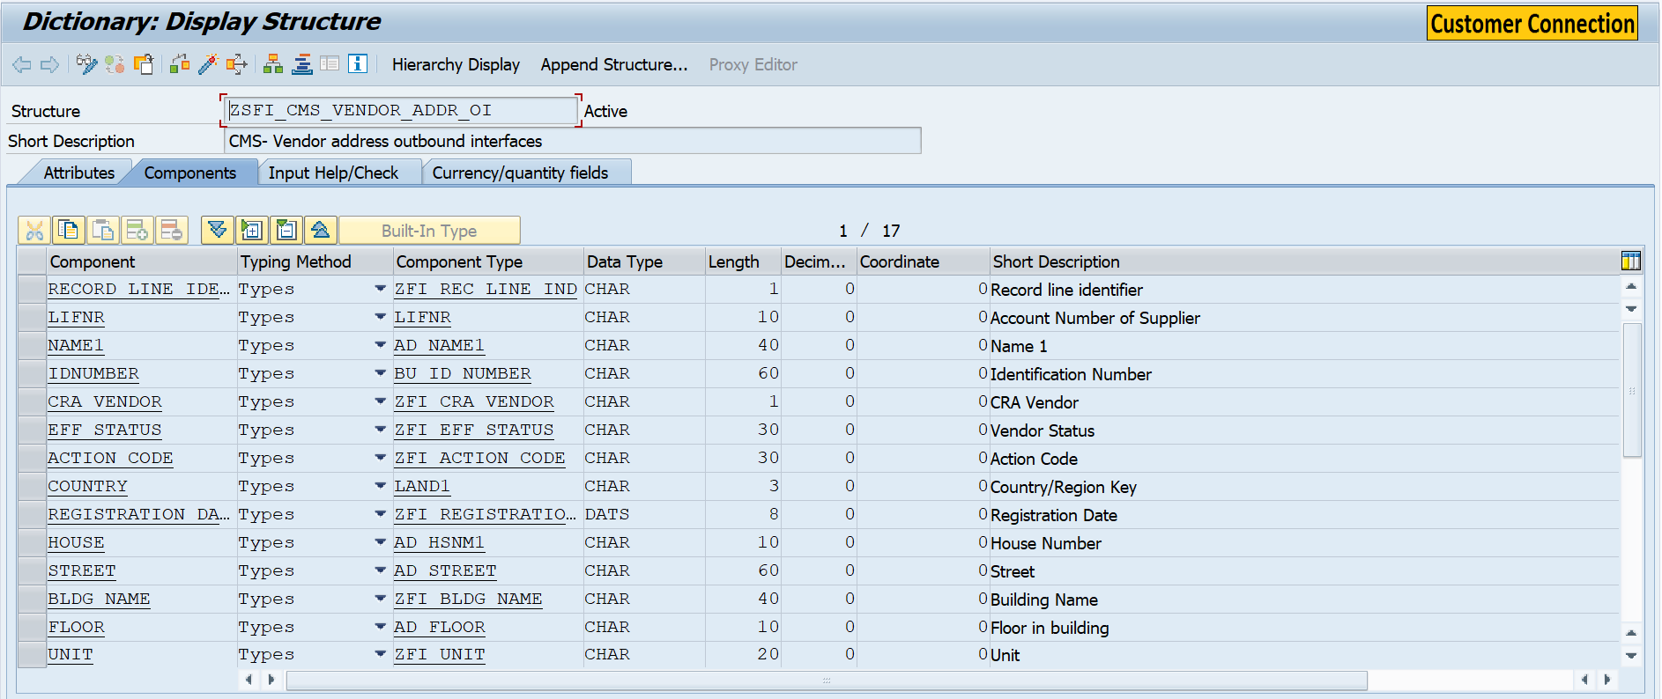
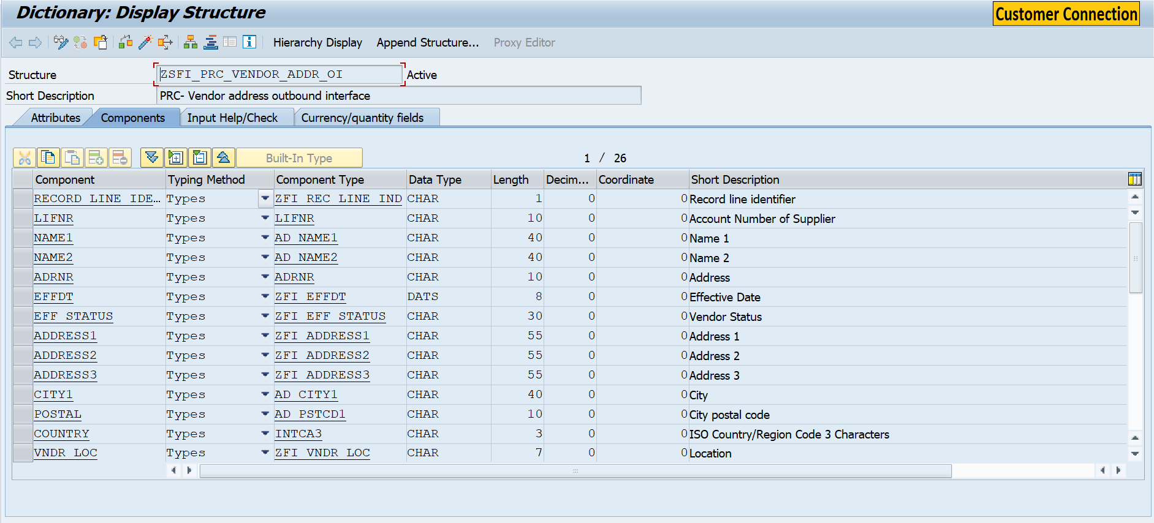
- Created Table Type ZTFI_CMS_VENDOR_ADDR_OI and ZTFI_PRC_VENDOR_ADDR_OI for above structure.
- Fetch data from CDS – ZI_VENDOR_ADDR_DETAILS.
- In the CDS fetch ObjectClas, Lifnr, ChangeNr Action_Code, Run_Date, Run_Time, Effdt_Vendor, Adrnr, Eff_Status_Lu, Land1, IdNumber, Effdt, Registration_Date, Eff_Status, VariableName, EAT, PMM, EAM, adrc.name1, adrc.name2, adrc.street, adrc.str_suppl1, adrc.str_suppl2, adrc.str_suppl3, adrc.city1, adrc.post_code1, adrc.house_num1, adrc.floor, adrc.building from table ZI_VEDNDOR_DETAILS association ADRC on ZI_VEDNDOR_DETAILS.ADRNR = ADRC_ADDRNUMBER, association T005 on ZI_VEDNDOR_DETAILS,LAND1 = T005.LAND1, association ZI_VENDOR_TVARVC_DETAILS on ZI_VENDOR_TVARVC_DETAILS.VARIABLENAME = ZI_VEDNDOR_DETAILS.VARIABLENAME.
- Pass the fetched data in the Proxy class. For Proxy creation see the below logic.
  - Created Function Group ZFI_FG_UTILITY_VENDOR_ADDR and Function Modules Z_FI_FM_CMS_VENDOR_ADDR_OI and Z_FI_FM_PRC_VENDOR_ADDR_OI with Importing and Exporting Parameter of type ZTFI_CMS_VENDOR_ADDR_OI and ZTFI_PRC_VENDOR_ADDR_OI respectively.
  - Created a Web Service ZFI_WS_CMS_VENDOR_ADDR and ZFI_WS_PRC_VENDOR_ADDR for the above Function Module
  - Created Service Consumer ZCO_ZFI_WS_CMS_VENDOR_ADDR and ZCO_ZFI_WS_PRC_VENDOR_ADDR for above mentioned Web Service.
  - Pass the Logical Port ZFI_PORT_VENDOR_ADDR and ZFI_PORT_VENDOR_ADDR in above mentioned consumer and pass the data in the proxy generated FM zfi_fm_cms_vendor_addr_oi and zfi_fm_prc_vendor_addr_oi.
- An ALV is displayed based on the records fetched from the table zfid_prc_ven_add and zfid_cms_ven_add

Validation
N/A

Mapping
N/A

Error Handling
N/A

Custom CDS View Entity Details

Custom CDS entity Name | ZI_FI_GL_MASTER_O_INTERFACE
Primary View
Associated Views

Custom CDS entity Name | ZI_FI_CC_MASTER_O_INTERFACE
Primary View
Associated Views

Custom CDS entity Name | ZI_FI_PC_MASTER_O_INTERFACE
Primary View
Associated Views

Custom CDS entity Name | ZI_FI_IO_MASTER_O_INTERFACE
Primary View
Associated Views

Custom CDS entity Name | ZI_FI_TP_MASTER_O_INTERFACE
Primary View
Associated Views

Custom CDS entity Name | ZI_FI_CO_MASTER_O_INTERFACE
Primary View
Associated Views

BRF+ Design
N/A

Reusable Code
N/A

File Attributes
N/A

Messages
N/A
Message Class | Message ID | Message Text

Selection Text
Name | Description
P_INT1 | NRS Interface
P_CMS | eCSS
P_DATE | Creation/Change On
P_DEL | Delete logs
P_PRC | EAM/EAT/PMM/WMS
P_SEND | Send data
S_DATE | Creation/Change On
S_LIFNR | Vendor

Text Elements
Name | Text Description
001 | Selection Screen
002 | Select format
003 | Select operation

Subroutines
Name | Description
CLEAR_VARIABLES | Clear Variables
DELETE_LOGS | Delete Duplicate Data
FETCH_DATA | Fetch Data
MAPPING | Map data to itab
MODIFY_SCREEN | Modify screen
PROCESS_CMS_DATA | Process CMS data
PROCESS_PRC_DATA | Process PRC data
SEND_CMS_DATA | Send CMS data
SEND_DATA | Send data
SEND_PRC_DATA | Send PRC data
VALIDATE_N_DEL_REC | Validate data

Interface List Output

Field Details
[Please list the fields for output]

Layout
[Please list the sequence of the fields in which the output must be displayed?
Or embed Excel sheet layout.]

Interface List Header & Footer
[If deviation from the project defined header and footer is required mention Interface List Header and Report Footer]

Application logs/Monitoring
[Include Application log object, sub object details.]

Assumptions in Technical Design

Open Issues in Technical Design

Unit Test Results
[Please indicate the Unit Test Results that should be used to verify successful operations of the Interface]
[Document all technical scenarios associated with this development. Examples would include 1) testing an error-free run; 2) testing the exception processes; 3) testing the error handling.]
[Document all control scenarios associated with this development. Examples would include 1) Rounding of dollars and cents; 2) Audit trail processing; 3) Reconciliation reporting]
IMPORTANT: Provide instructions to reverse the actions performed so the test may be run again, or explain how to create new input data to the test.
Scenario # | Input Selection Criteria | Expected Result | Actual Test Pass/Fail
 |  |  | Choose an item.
 |  |  | Choose an item.
 |  |  | Choose an item.

Related Documentation
[Attach OSS notes, emails, download of existing report, etc.]

Template Version

Version | Status | Date | Version Created by | Reviewer | Approver | Comments
1.0 | Final | February 11, 2019 | Abhishek Nayak | Jagmeet Singh | Modak Gupta | Initial version created
2.0 | Final | Oct 18, 2023 | Ravish Ranka | Jagmeet Singh | Modak Gupta | Updates according to latest development guideline

